Child Safeguarding Risk Reflection  This tool will be used to establish if there are child safeguarding risks which the partner organisation has a duty of care* to mitigate against.  If there are any child safeguarding risks identified through this process, the project must meet all the requirements set out in the ‘Minimum Requirements for Child Safeguarding of Partners’.  Note: For the purposes of this exercise, ‘personnel’ refers to any persons employed or conducting a service within the project the partner organization is implementing and includes employees, interns, volunteers, contractors, consultants and any religious or lay assigned who work in the project or are assigned to reside on the grounds of the project.  Please complete and return to Name of XN Member. Thank you.  Section A:  Name:  Role:  Partner Organisation:  Date:  Risk 1: Do personnel have contact with children who are under your organisation’s care*?  Yes | No  Risk 2: Do personnel have contact with children who are not under your care during their work hours and duties? (e.g. field visits, community events, etc)  Yes | No  Instructions: If you have answered Yes to either of the above question, you have completed the risk reflection. If you have answered No to both above, please continue to Section B. |  | Child Safeguarding Risk Reflection  Section B:  Risk 3: Have personnel received written information of the responsible person in your organisation and contact details of statutory authorities in case of any child safeguarding concerns regarding colleagues or the people in the local community?  Yes | No  Risk 4: Are there any written Dignity & Ethics Policies/ Code of Conducts or equivalent which personnel are required to sign, which include child safeguarding elements such as:  - Inappropriate or misuse of images of children  - accessing child pornography  - prohibiting personnel having sexual intercourse or participation in any form of sexual activity, including paying for sex, with any person under a specified age?  Yes | No  Risk 5: Does your organisation use images of children in your communication?  Yes | No  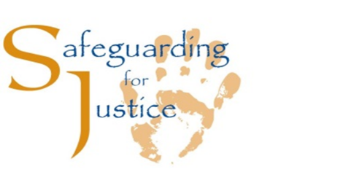  Instructions for Name of XN Member: Please see the XN CS Manual for Programme Teams for the Agreed Actions to the above responses.
*Note: Duty of Care is when and organisation has:
- programmes or activities that involve children
- programmes or activities that do not directly involve children, but children are present. One example is a programme targeting Single Mothers where children are brought to workshops or staff are visiting beneficiaries’ homes where children are present. A second example is an office compound that children are present on, e.g. visiting or being minded by a parent working on the compound.

