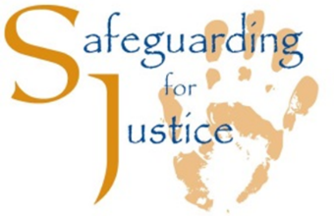
Minimum Requirements in Child Safeguarding of XN Members

As a XN Member, the below minimum requirements in child safeguarding must be adhered to.
Minimum Requirements in Child Safeguarding of XN Members
Requirement 1: XN Members must be implementing comprehensive child safeguarding policy and/or procedures which are signed off by the Director or leadership in the Province.
Requirement 2: XN Members must appoint at least one designated person for child safeguarding is appointed at project level.
Requirement 3: XN Members must give all new personnel an induction to the child safeguarding policy/procedures.
Requirement 4: As a condition of employment, personnel at the XN Member must:
  - Provide at least one written reference from a previous employer or education body, if they have had previous employment or education. The XN Member must make attempts to contact that referee, preferably in writing, to verify details given.
  - Provide a police certificate if police vetting is provided in that country
  - Sign an Acceptance Form indicating they've read, understand and will abide by the child safeguarding policy
  - Sign a Self-Disclosure form indicating if they have ever been convicted of a sexual or child safeguarding offence or are subject to an on-going sexual or child safeguarding investigation
Requirement 5: A Child Safeguarding Statement must be displayed in the offices of the XN Member where personnel can view it indicating the contact details for the Child Safeguarding Officer (CSO), the Deputy CSO (if appointed) and the local statutory authorities.

The XN is committed to the protection of all children under 18, in line with the Committee of the Rights of the Child, the monitoring body for the Convention on the Rights of the Child, which has encouraged States to review the age of majority if it is set below 18. The definition of a child for the purposes of safeguarding and protection should not be confused with age limits set out in other relevant laws. The fact that a person under the age of 18 may have reached the local age of majority, age of sexual consent, voting age or such like does not alter their inherent vulnerability as a child.

